SW Requirements Specification

CSE, HCMUT

|  |  |  |  |
| --- | --- | --- | --- |
| **Project Name** | *mPlayer – MP3 Player* | | |
| **Date** | *10/05/2013* | **Version** | *Version – 1.0* |
| **Author** | *Nguyen Van Hung*  *Ho Nhut Minh*  *Huynh Khanh Phong* | **Approver** | *PhD. Vu Tuan Thanh* |
| **Organization** | *Embedded System Class - Faculty of Computer Science and Engineering – HCMC University of Technology* | | |

**Revision History**

|  |  |  |  |  |
| --- | --- | --- | --- | --- |
| **Version** | **Date:** | **Change Contents** | **Author** | **Approver** |
| *0.1* | *10/03/2013* | *Document created.* | *Hung* |  |
| *1.0* | *10/05/2013* | *UI Scenario, System Structure* | *Minh, Hung* |  |
|  |  |  |  |  |
|  |  |  |  |  |
|  |  |  |  |  |
|  |  |  |  |  |
|  |  |  |  |  |
|  |  |  |  |  |
|  |  |  |  |  |
|  |  |  |  |  |

Contents

1 System Structure 4

1.1 System structure 4

1.2 Modules 4

1.3 Connections 4

2 SW Functional Requirements 6

2.1 Detailed Function Requirements 6

2.1.1 List files on SD Card 6

2.1.2 Play music files 6

2.1.3 Display song’s lyrics on LCD corresponding to playing song 7

2.1.4 Playing control by navigator button 7

2.1.5 Many playing mode: repeat one, repeat all, shuffle, and adjust volume 8

2.1.6 Read txt file and display to LCD screen 8

2.1.7 Stream file from HTTP server and play it. 9

3 SW Non-functional Requirements 10

4 Interface Requirements 11

4.1 System Interfaces 11

4.2 User Interfaces 11

4.2.1 UI Basic Requirements (Including Icons and Fonts) 11

4.2.2 UI Scenario 12

5 Coverage of SW Standardization and Reuse 13

6 Operation Environment 14

# System Structure

## System structure

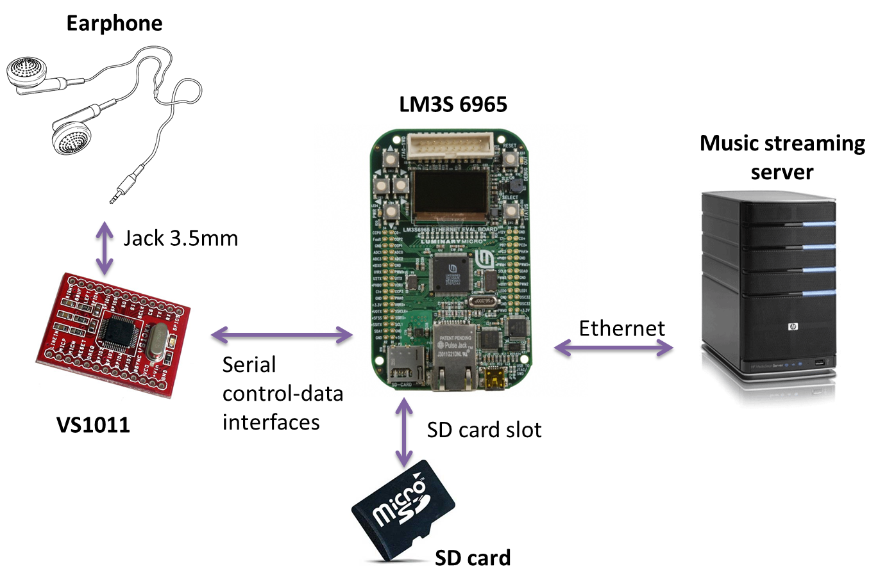

The system structure contain the main component is the controller module board which is use LM3S6965 microcontroller. Controller will read data from micro-SD card, then by serial control-data interfaces send data to the decoder board VS1011, then user can listen to music by connect earphone to VS1011 board. Another way to play music is through Ethernet connection, the controller get audio data from a music-streaming server

## Modules

|  |  |  |
| --- | --- | --- |
| # | Module | Detail |
| 1 | LM3S 6965 | The Stellaris® LM3S6965 microcontroller - based on the ARM® Cortex™-M3 controller core. |
| 2 | VS 1011 | The VS1011 is basic MP3 decoder chip. |
| 3 | SD card | Storage for music and file |
| 4 | Music streaming server | A server that will stream music through Ethernet. In this project we will implement it with a laptop |
| 5 | Earphone | Typical earphone |

## Connections

|  |  |  |
| --- | --- | --- |
| # | Connection | Detail |
| 1 | Serial control – data interfaces | Standard of one way to transmitting data packets over a Serial Digital Interface DataStream |
| 2 | SD card slot | Built in slot for SD card on LM3S 6965 |
| 3 | Ethernet | Built in Ethernet module on board LM3S 6965 |
| 4 | Jack 3.5mm | Jack 3.5mm very popular |

# SW Functional Requirements

| **No.** | **Req. ID** | **Req. Name** | **Remark** |
| --- | --- | --- | --- |
| *1* | MPL – S01 | List files on SD Card |  |
| *2* | MPL – S02 | Play music files |  |
| *3* | MPL – S03 | Display song’s lyrics on LCD corresponding to playing song |  |
| *4* | MPL – S04 | Playing control by navigator button |  |
| *5* | MPL – S05 | Many playing mode: repeat one, repeat all, shuffle, and adjust volume |  |
| *6* | MPL – S06 | Read txt file and display to LCD screen |  |
| *7* | MPL – S07 | Streams file from HTTP server and play it. |  |

## Detailed Function Requirements

### List files on SD Card

|  |  |
| --- | --- |
| **Name of Requirement** | List files and directory on SD Card and USB Stick |
| **Requirement ID** | MPL – S01 |
| **Description** | Read file list on FAT32 File System from SD card. And then display it on LCD and user can also navigate through directories to all file. |
| **Pre-Condition** | SD card in FAT32 format |
| **Basic Flow** | <SD card>🡪<File system>🡪<Center Control>🡪<Display> |
| **Alternative Flow 1** | N/A |
| **Alternative Flow 2** | N/A |
| **Exceptional Flow** | N/A |
| **Post-Condition** | N/A |
| **Test Procedure** | Copy data to SD card by PC, then test on board. |
| **Related Requirements** | N/A |
| **Constraints** | N/A |
| **Standardization** | N/A |
| **Implemented** | Hardware ready |

### Play music files

|  |  |
| --- | --- |
| **Name of Requirement** | Play music files |
| **Requirement ID** | MPL – S02 |
| **Description** | Play mp3 file and output to 3.5mm audio jack. In addition, the user can listen to music by headphone or another speaker. |
| **Pre-Condition** | Hardware module with codec unit and jack 3.5 must be implemented first. |
| **Basic Flow** | <File System>🡪<VS1011 Interface>🡪<Play music> |
| **Alternative Flow 1** | N/A |
| **Alternative Flow 2** | N/A |
| **Exceptional Flow** | N/A |
| **Post-Condition** | N/A |
| **Test Procedure** | Always wear a headphone when testing. Remember to set to volume to minimum, avoid loud sound may harm our ears. |
| **Related Requirements** | MPL – S01: read MP3 file. |
| **Constraints** | N/A |
| **Standardization** | N/A |
| **Implemented** | N/A |

### Display song’s lyrics on LCD corresponding to playing song

|  |  |
| --- | --- |
| **Name of Requirement** | Display song’s lyrics on LCD corresponding to playing song |
| **Requirement ID** | MPL – S03 |
| **Description** | Read lrc lyric file, detect the time for each sentence and display by text on LCD |
| **Pre-Condition** | Lyric file have the same name with MP3 file saved in SD card in the same folder. |
| **Basic Flow** | <SD card>🡪<File system>🡪<Center Control>🡪<Display> |
| **Alternative Flow 1** | N/A |
| **Alternative Flow 2** | N/A |
| **Exceptional Flow** | N/A |
| **Post-Condition** | N/A |
| **Test Procedure** | Copy data to SD card by PC, then test on board. |
| **Related Requirements** | MPL – S01 : read file |
| **Constraints** | N/A |
| **Standardization** | N/A |
| **Implemented** | N/A |

### Playing control by navigator button

|  |  |
| --- | --- |
| **Name of Requirement** | Playing control by navigator button |
| **Requirement ID** | MPL – S04 |
| **Description** | By 5 buttons on board, user can adjust volume, choose next song, previous song, go to menu to make configuration like: many playing mode: repeat one, repeat all, shuffle, and adjust volume; choose music file; on/off lyric displaying. |
| **Pre-Condition** | File system must work well. |
| **Basic Flow** | <Buttons>🡪{<Center control>🡨🡪<File system>}🡪<Display > |
| **Alternative Flow 1** | N/A |
| **Alternative Flow 2** | N/A |
| **Exceptional Flow** | N/A |
| **Post-Condition** | N/A |
| **Test Procedure** | Check buttons first. |
| **Related Requirements** | MPL – S01, MPL – S02, MPL – S03 |
| **Constraints** | N/A |
| **Standardization** | N/A |
| **Implemented** | Hardware ready |

### Many playing mode: repeat one, repeat all, shuffle, and adjust volume

|  |  |
| --- | --- |
| **Name of Requirement** | Many playing mode: repeat one, repeat all, shuffle, and adjust volume |
| **Requirement ID** | MPL – S05 |
| **Description** | This function will bring more satisfy and interesting to user when listening to music. |
| **Pre-Condition** | Play music work well |
| **Basic Flow** | <Read config data>🡪<Center control>🡪<Display > |
| **Alternative Flow 1** | N/A |
| **Alternative Flow 2** | N/A |
| **Exceptional Flow** | N/A |
| **Post-Condition** | N/A |
| **Test Procedure** | At the later phase of project, when other function work well. |
| **Related Requirements** | MPL – S04 |
| **Constraints** | N/A |
| **Standardization** | N/A |
| **Implemented** | N/A |

### Read txt file and display to LCD screen

|  |  |
| --- | --- |
| **Name of Requirement** | Read txt file and display to LCD screen |
| **Requirement ID** | MPL – S06 |
| **Description** | Read from SD card, choose txt file and the display content of this file to LCD screen page by page. |
| **Pre-Condition** | Read SD card |
| **Basic Flow** | <User>🡨🡪<Center control>🡪<Read file>🡪<Display> |
| **Alternative Flow 1** | N/A |
| **Alternative Flow 2** | N/A |
| **Exceptional Flow** | N/A |
| **Post-Condition** | N/A |
| **Test Procedure** | Put file with content to SD card. Then check that content on LCD. |
| **Related Requirements** | N/A |
| **Constraints** | N/A |
| **Standardization** | N/A |
| **Implemented** | N/A |

### Stream file from HTTP server and play it.

|  |  |
| --- | --- |
| **Name of Requirement** | Stream file from HTTP server and play it. |
| **Requirement ID** | MPL – S07 |
| **Description** | With Ethernet cable connected to a HTTP server, board will get the stream file and play to headphone |
| **Pre-Condition** | HTTP server set up. |
| **Basic Flow** | <Player>🡨🡪<Central control>🡪<Ethernet interface> |
| **Alternative Flow 1** | N/A |
| **Alternative Flow 2** | N/A |
| **Exceptional Flow** | N/A |
| **Post-Condition** | N/A |
| **Test Procedure** | Test with VLC player, can creates a http streaming server. |
| **Related Requirements** | N/A |
| **Constraints** | N/A |
| **Standardization** | N/A |
| **Implemented** | N/A |

# SW Non-functional Requirements

| **No.** | **Req. ID** | **Req. Name** | **Detail** |
| --- | --- | --- | --- |
| *1* | MPL-S-01 | Play music continuously | No pause or silence time |
| *2* | MPL-S-02 | Change song | <1 second |
| *3* | MPL-S-03 | Music file support | MP3 |
| *4* | MPL-S-04 | Button response in LCD | <100 ms |
| *5* | MPL-S-05 | Play for long time | No stop or turn off accidently |
| 6 | MPL-S-06 | Read content correctly | The text content correct to the content that we input from PC |
| 7 | MPL-S-07 | Play music continuously | No pause or silence time |

# Interface Requirements

## System Interfaces

|  |  |
| --- | --- |
| **External system overview** | Music codec unit + 3.5 jack |
| **Standard** | N/A |
| **Reference SW** | *Playing music file* |
| **Requirement** | *Must implement the hardware: codec chip and 3.5 jack.* |
| **Constraints & Issue** | *N/A* |

## User Interfaces

### UI Basic Requirements (Including Icons and Fonts)

| **Item** | **Content** |
| --- | --- |
| Input device | 5 buttons |
| Panel Resolution | N/A |
| LCD Graphic size | 128x96 |
| Aspect Ratio | N/A |
| Graphic Chip Name | N/A |
| Color depth | 4bit |
| GUI Unit | Pixel |
| Image Format | N/A |
| Font Type | True Type |
| Language | English |
| Font Name | N/A |
| Font Size | 10 px high per character |

### 

### UI Scenario



|  |  |  |
| --- | --- | --- |
|  | **Item** | **Attachment** |
| 1 | Welcome windows. Also initialize device and driver. | C:\StellarisWare\tools\bin\p\welcome.jpg |
| 2 | Music playing window. This is main function that play music file, display lyrics when playing, play in many playing mode: repeat, shuffle. | C:\StellarisWare\tools\bin\result\music.jpg |
| 3 | Setting window. Here user can configure repeat and shuffle options | C:\StellarisWare\tools\bin\result\setting.jpg |
| 4 | E-book reader window. User can browse a list of txt file and choose file to read | C:\StellarisWare\tools\bin\result\ebook.jpg |
| 5 | Internet radio window. User can listen to music from a remote music streaming server. | C:\StellarisWare\tools\bin\result\radio.jpg |

# Coverage of SW Standardization and Reuse

| **Name of Component (or Module)** | **Standardization** | **Reuse** | **Newly-added** |
| --- | --- | --- | --- |
| File system | O | X | O |
| Display | O | X | O |
| Controller | O | X | O |
| Read file content | O | X | O |
| VS1011E Interface | O | X | O |
| Ethernet | O | X | O |

# Operation Environment

| **Item** | **Environment** | **Remarks** |
| --- | --- | --- |
| Evaluation board | Stellaris LM3S6965 Ethernet Evaluation Kit |  |
| Microcontroller | LM3S6965 | 32-bit ARM® Cortex™-M3  50-MHz operation |
| RAM | 64 KB single-cycle SRAM |  |
| Flash memory | 256 KB single-cycle Flash |  |
| Input device | 5 buttons input from GPIO pin |  |
| Display | OLED graphics display with128 x 96 pixel resolution |  |
| Ethernet | Fully-integrated 10/100 embedded Ethernet controller |  |
| Mp3 Decoder | VS1011E or higher | Other mp3 decoders can be used in this project, but VS1011E is the cheapest one |
| SD card | Micro SD 2GB |  |
| Jack 3.5mm | Standard 3.5 mm audio jack |  |